Lecture 15
CO1: Apply the knowledge about the concepts of probability and statistics for the computer applications.
CO2: Evaluate the ideas of probability and random variables and various discrete and continuous probability distributions and their properties.

CONTINUOUS PROBABILITY DISTRIBUTIONS
Let us now consider a situation, where the variable of interest may take any value within a given range. Suppose that we are planning to release water for hydropower generation and irrigation. Depending on how much water we have in the reservoir, viz., whether it is above or below the ‘normal’ level, we decide on the quantity of water and time of its release. The variable indicating the difference between the actual level and the normal level of water in the reservoir, can take positive or negative values, integer or otherwise. Moreover, this value is contingent upon the inflow to the reservoir, which in turn is uncertain. This type of random variable which can take an infinite number of values is called a continuous random variable, and the probability distribution of such a variable is called a continuous probability distribution.
Now we present one important probability density function (p.d.f), viz., the normal distribution.
Normal Distribution
The normal distribution is the most versatile of all the continuous probability distributions. It is useful in statistical inferences, in characterising uncertainties in many real life situations, and in approximating other probability distributions. As stated earlier, the normal distribution is suitable for dealing with variables whose magnitudes are continuous. Many statistical data concerning business problems are displayed in the form of normal distribution. Height, weight and dimensions of a product are some of the continuous random variables which are found to be normally distributed. This knowledge helps us in calculating the probability of different events in varied situations, which in turn is useful for decision-making. To define a particular normal probability distribution, we need only two parameters i.e., the mean (µ) and standard deviation (σ).
Now we turn to examine the characteristics of normal distribution with the help of the figure, and explain the methods of calculating the probability of different events using the distribution.
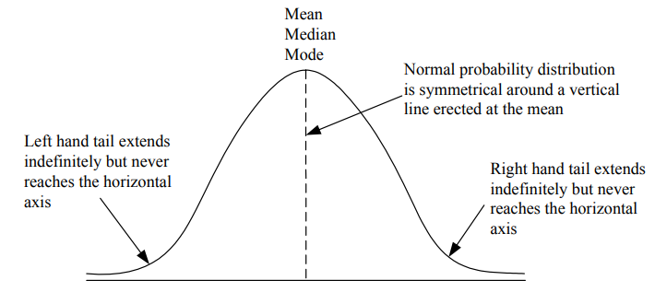
Figure: Frequency Curve for the Normal Probability Distribution

Characteristics of Normal Distribution
- The curve has a single peak, thus it is unimodal i.e., it has only one mode and has a bellshape.
- Because of the symmetry of the normal probability distribution (skewness = 0), the median and the mode of the distribution are also at the centre. Thus, for a normal curve, the mean, median and mode are the same value.
- The two tails of the normal probability distribution extend indefinitely but never touch the horizontal axis.

Areas Under the Normal Curve
The area under the normal curve gives us the proportion of the cases falling between two numbers or the probability of getting a value between two numbers.
Irrespective of the value of mean (µ) and standard deviation (σ), for a normal distribution, the total area under the curve is 1.00. The area under the normal curve is approximately distributed by its standard deviation as follows:
µ ± 1σ covers 68% area, i.e., 34.13% area will lie on either side of µ.
µ ± 2σ covers 95.5% area, i.e., 47.75% will lie on either side of µ.
µσ ± 3σ covers 99.7% area, i.e., 49.85% will lie on either side of µ.

Using the Standard Normal Table
The areas under the normal curve are shown in the Appendix Table-3 at the end of this block. To use the standard normal table to find normal probability values, we follow two steps. They are:
Step 1: Convert the normal distribution to a standard normal distribution. The standard random variable Z, can be computed as follows:
$Z=\frac{X-μ}{σ}$.
Where,
X = Value of the random variable with which we are concerned.
µ = mean of the distribution of this random variable
σ = standard deviation of this distribution.
Z = Number of standard deviations from X to the mean of this distribution.
Step 2: Look up the probability of z value from the Appendix Table-3, given at the end of this block, of normal curve areas. This Table is set up to provide the area under the curve to any specified value of Z. (The area under the normal curve is equal to 1. The curve is also called the standard probability curve).
Let us consider the following illustration to understand as to how the table should be consulted in order to find the area under the normal curve.

Illustration 8
(a) Find the area under the normal curve for Z = 1.54.
Solution: Consulting the Appendix Table-3 given at the end of this block, we find the entry corresponding to Z = 1.54 the area is 0.4382 and this measures the Shaded area between Z = 0 and Z = 1.54 as shown in the following figure.
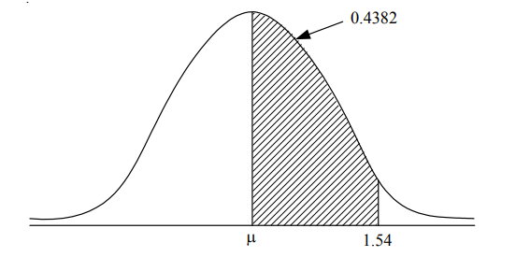
(b) Find the area under normal curve for Z = -1.46
Solution: Since the curve is symmetrical, we can obtain the area between z = ñ1.46 and Z = 0 by considering the area corresponding to Z = 1.46. Hence, when we look at Z of 1.46 in Appendix Table-3 given at the end of this block, we see the probability value of 0.4279. This value is also the probability value of Z = ñ1.46 which must be shaded on the left of the µ as shown in the following figure.
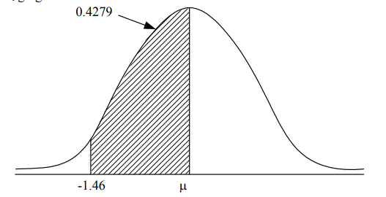
(c) Find the area to the right of Z = 0.25
Solution: If we look up Z = 0.25 in Appendix table, we find the probable area of 0.0987. Subtract 0.0987 (for Z = 0.25) from 0.5 getting 0.4013 (.5 - .0987 = 0.4013).
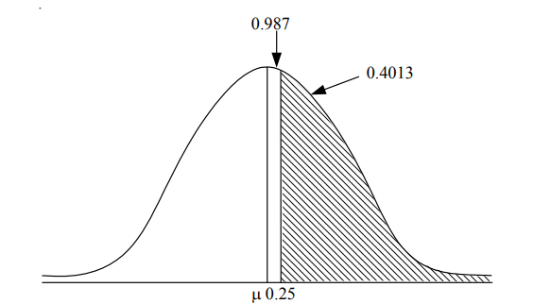
d) Find the area to the left of Z = 1.83.
Solution: If we are interested in finding the area to the left of Z (positive value), we add 0.5000 to the table value given for Z. Here, the table value for Z (1.83) = 0.4664. Therefore, the total area to the left of Z = 0.9664 (0.5000 + 0.4664) i.e., equal to the shaded area as shown below:
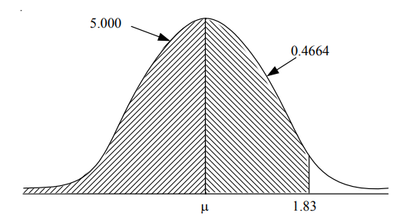
Now let us take up some illustrations to understand the application of normal probability distribution.
Illustration 9
Assume the mean height of soldiers to be 68.22 inches with a variance of 10.8 inches. How many soldiers in a regiment of 1,000 would you expect to be over six feet tall?
Solution: $Z=\frac{X- µ}{σ}$
X = 72 inches; µ = 68.22 inches; and σ = $\sqrt{10.8}$ = 3.286
∴ $Z=\frac{72- 68.22}{3.286}=1.15$
for Z = 1.15 the area is .3749 (Appendix Table-3).
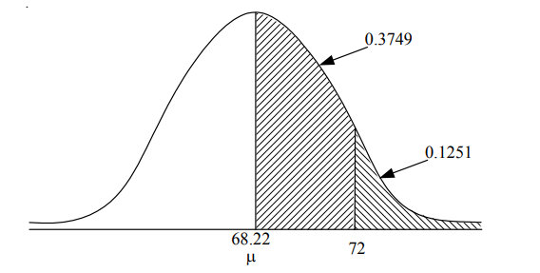
Area to the right of the ordinate at 1.16 from the normal table is (0.5 - 0.3749) = 0.1251. Hence, the probability of getting soldiers above six feet is 0.1251 and out of 1,000 soliders, the expectation is 1,000 × 0.1251 = 125.1 or 125. Thus, the expected number of soldiers over six feet tall is 125.
Illustration 10
- 15,000 students appeared for an examination. The mean marks were 49 and the standard deviation of marks was 6. Assuming the marks to be normally distributed, what proportion of students scored more than 55 marks?
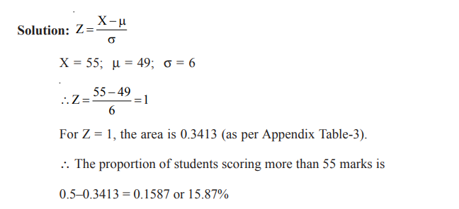
- If in the same examination, Grade ‘A’ is to be given to students scoring more than 70 marks, what proportion of students will receive grade ‘A’?

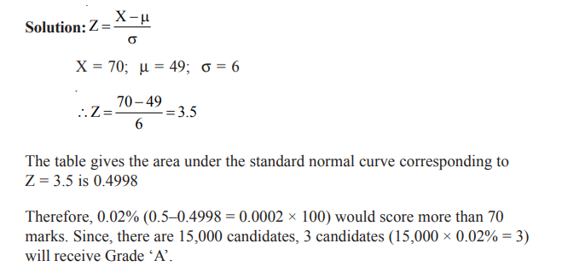

Illustration 11
In a training programme (self-administered) to develop marketing skills of marketing personnel of a company, the participants indicate that the mean time on the programme is 500 hours and that this normally distributed random variable has a standard deviation of 100 hours. Find out the probability that a participant selected at random will take:
- fewer than 570 hours to complete the programme, and
- between 430 and 580 hours to complete the programme.
Solution:
- To get the Z value for the probability that a candidate selected at random will take fewer than 570 hours, we have
$Z=\frac{X- µ}{σ}=\frac{570-500}{100}=\frac{70}{100}=0.7$
Consulting the Appendix Table-3 for a Z value of 0.7, we find a probability of 0.2580 (this probability will lie between the mean, 500 hours and 570 hours. As explained in illustration 8(d), we must add 0.5 to this probability (0.2580) that the random variable will be between the left-hand tail and the mean.
Therefore, we obtain the probability that the random variable will lie between the left-hand tail and 570 hours is 0.7580 (0.5 + 0.2580). This situation is shown below:
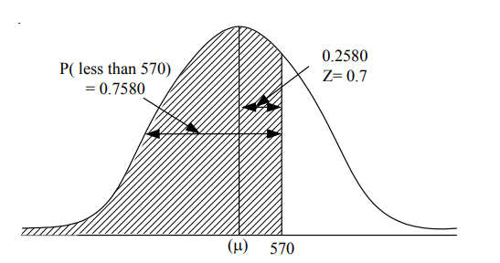
Thus, the probability of a participant taking less than 570 hours to complete the programme, is marginally higher than 75 per cent.
- In order to get the probability, of a participant chosen at random, that he will take between 430 and 580 hours to complete the programme, we must, first, compute the Z value for 430 and 580 hours.
$$Z=\frac{X- µ}{σ}$$
$$Z for 430=\frac{430-500}{100}=\frac{-70}{100}=-0.7$$
$$Z for 580=\frac{580-500}{100}=\frac{-80}{100}=-0.8$$
The table shows the probability values of Z values of -0.7 and 0.8 are 0.2580 and 0.2881 respectively. This situation is shown in the following figure.
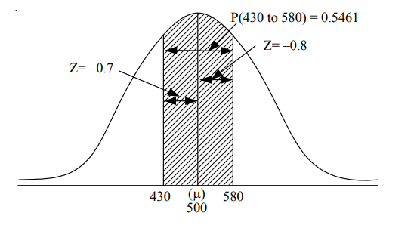
Thus, the probability that the random variables lie between 430 and 580 hours is 0.5461 (0.2580 + 0.2881).

Importance and Application of Normal Distribution
This distribution was initially discovered for studying the random errors in measurements, which are encountered during the calculations of orbits of heavenly bodies. It happens because of the fact that the normal distribution follows the basic principle of errors. It is mainly for this quality that the distribution has a wide range of applications in the theory of statistics. To count a few:
Industrial quality control
- Testing of significance
- Sampling distribution of various statistics
- Graduation of non-normal curve
- length of the leaves observed at particular times of the year.
The main purpose for using a normal distribution are:
- To fill a distribution of measurement for same sample data,
- To approximate the distributions like Binomial, Poisson etc.
- To fit sampling distribution of various statistics like mean or variance etc.

Practice Questions
  - Given a standardized normal distribution area between the mean and positive value of Z as in Appendix Table 2) what is the probability that:
  - Z is less than +1.08?
  - Z is greater than ñ 0.21?
  - Z is between the mean and +1.08?
  - Z is less than ñ 0.27 the mean and greater than +1.06?
  - Z is between ñ 0.21 and the mean?
  - Give a normal distribution with µ = 100 and σ = 10, what is the probability that:
    - X > 75?
    - X < 70?
    - X > 112?
    - 75 < X > 85?
    - X < 80 or X > 110?

TEXT BOOKS
- T1 = H. K Dass, Higher Engineering Mathematics, S. Chand Publishers,3rd revised edition.2014.
- T2 = B.S. Grewal, Higher Engineering Mathematics, Khanna Publishers,42th ed.2013, New Delhi.
- T3= N. P. Bali and Manish Goyal, A textbook of engineering Mathematics, Laxmi Publications, Reprint 2008.

REFERENCE BOOKS
- R1=R. K. Jain and S. R. K. Lyenger, Advanced Engineering Mathematics ,3rd Edition Narosa Publishing House ,2004,New Delhi.
- R2 =B. V. Ramana Advanced Engineering Mathematics, McGrawHill, July2006, New Delhi.
- S.P.Gupta,StatisticalMethods,S.Chand&Sons,2017,NewDelhi,ISBN9789351610281Insiders’Guide

Video Lecture :
https://www.youtube.com/watch?v=c06FZ2Yq9rk

